Dublin Burial Grounds

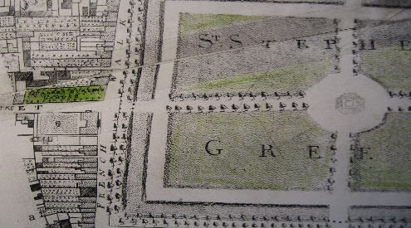
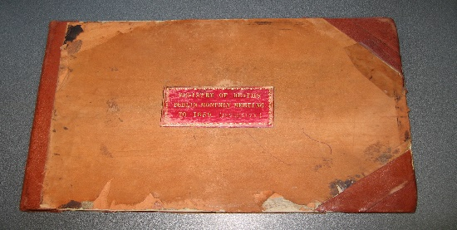
Detail of Rocque’s map showing Register of Deaths Dublin Monthly Meeting up to 1859
Stephen’s Green burial ground

Three Quaker burial grounds exist in Dublin. Temple Hill, Blackrock has been in use since 1860. Previously, there was one in Cork Street and an earlier one in Stephen’s Green.

The premises in Stephen’s Green was acquired in 1674 at the corner of York Street. It measured 78 x 30 yards. It is depicted on John Rocque’s map of Dublin, published in 1756.

The premises in Cork Street was owned by Roger Roberts, a Quaker and innkeeper at the adjoining Marrowbone Lane. He bequeathed it in his will of 1697 “to Dublin Quakers”, along with “my field at Roper’s Rest [opposite the National Stadium, South Circular Road] for Friend’s horses while they are at Meeting”. Cork Street burial ground was immediately enclosed by a high wall. Much of it still remains although somewhat dilapidated and neglected. A poor house was built adjoining the plot in 1707. Across the road, the Cork Street Fever Hospital opened in 1804. Quakers were instrumental in setting up and managing the hospital until its sale in 1953 and move to Cherry Orchard Hospital, Ballyfermot. Alongside the Cork Street burial ground, the James Weir Home for Nurses was built in 1903. It accommodated the hospitals’ nurses until the early 1980s and after that, patients of Brendan’s Hospital. The burial ground was first leased by Dublin Quakers to the Cork Street Fever Hospital in the early 1900s to be used as a garden for its nurses. It was sold to the hospital in the early 1970s. The deed of sale gives a right of access to Dublin Friends.

Recently, there have been articles and letters on the Cork Street cemetery and on the Weir Home for Nurses; mainly in the Irish Times and Dublin Inquirer newspapers. Apparently, the HSE is committed to the Nurses Home being transferred to the Peter McVerry Trust for conversion into social housing apartments for people leaving homelessness. Rob Goodbody, the Quaker historian and Historic Building Consultant, was commissioned by the HSE to write a Survey and Maintenance Plan on Cork Street burial ground. His wide-ranging and detailed report, completed in June, seeks to ensure that any maintenance plan for Cork Street is backed by an understanding of its historical background, and related Quaker beliefs and practices.

A Register entitled “Registry of Deaths Dublin Monthly Meeting up to 1859” in Friend’s Historical Library records details of 4,847 deaths of members. It is arranged alphabetically and chronologically. This Register, along with 45 uniform Registers, provide details of births, marriages and deaths of Quakers in all Monthly Meeting areas. They were drawn up to comply with a proposal to extend the Non-parochial Registers Act 1840 to non-conformist congregations and churches in Ireland. That law would have established a General Registry of births marriages and deaths for all denominations in Ireland. Friends conducted extensive demographical research in the 1850s and 1860s, from the earliest records of Quakers in Ireland, up to records of 1860. These measures were minuted in Monthly and Yearly Meetings. In the event, the proposed law was never enacted. Therefore, Friend’s Historical Library still retains originals which were expected to be handed over to the Government for central storage.

The earliest deaths recorded in the Dublin Monthly Meeting Register occurred before the Quaker burial ground in Stephen’s Green was purchased in 1674. They number 63. The most recent are in 1860, the year of the first interment in Temple Hill, Blackrock.

The locations of the burials are overwhelmingly recorded as being “Dublin”. That would be in Stephen’s Green from 1674 till 1805, and in Cork Street (sometimes given as “Dolphins Barn”) from 1697. Cork Street was closed for burials in 1868 as burials within a specified distance of a dwelling became legally prohibited. On the sale of Stephen’s Green burial ground to the College of Surgeons in 1805 the remains there were exhumed and re-interred in Cork Street. This would have included 394 burials recorded in the Register before Cork Street was opened in 1697.

Interments of 225 members of Dublin Monthly Meeting are recorded as being in places other than Dublin. These include New Garden, County Carlow, Ballymurrinmore, County Wicklow and the Barrington family burial ground. Within the Registers pertaining to the Monthly Meetings outside Dublin, interments of 79 persons are recorded as being in Stephen’s Green or in Cork Street. One third of these were from Mountmellick and Edenderry. An exception to all is that of Joseph Pim in 1854 recorded as being “The Ocean”.

The use of Cork Street burial ground, with its 170 x 180 feet dimensions, was extended by overlaying soil excavated from construction of the nearby Grand Canal in the 1790s.

The Dublin Monthly Meeting Deaths Register gives the same details for prominent Quaker family members as for less well-known members. It includes 61 Bewley, 59 Pim, 23 Webb, 20 Pike and 8 Fade family members. It also records if the deceased was a “Non Member”. 1,088 such are recorded. Their burials, in accord with usual practice, were not discouraged in Quaker burial grounds.

From these Registers, the total number of burials in Cork Street before 1860 is 4,847, less the 225 outside Dublin, plus the 79 in Dublin, that is, 4,701 burials.

Another Register entitled "Burials in Cork Street 1847-1866" is in the Friend’s Historical Library. It details 20 burials between 1860 and 1866 which were not included in the Monthly Meeting Registers. Also, between 1848 and 1856, one in five were of children less than 11 years old.

Thus, the above Registers record the total number of burials in Cork Street burial ground, as being 4,721.
Yearly Meeting did not decide until 1856 that placing of inscribed stones over a grave could be permitted without a violation of testimony. Extant paper records of deaths have proved equally long lasting as stone inscriptions. There are 18 headstones in Cork Street. Only one is upright. They mark 20 burials. During the 12 years, when headstones were approved until closure of Cork Street in 1868, there were 59 burials with no headstones.
On 15th September 2019, the Liberties Cultural Association hosted a gathering at the Nurses Home on “The Quakers’ burial grounds” and on “Trades of Cork Street”. It was well attended. Roy spoke briefly about the burial ground’s history and the burials there. There was considerable interest in this little known and unmarked part of Dublin’s cultural heritage. Local interest in the complex developed during 2019 because of plans for a change of ownership and use of the adjoining James Weir Home. It is hoped that the City Council will adopt the burial ground for use as a public park. Should this proceed, Dublin Friends will encourage the installation of a suitable memorial on its past use.

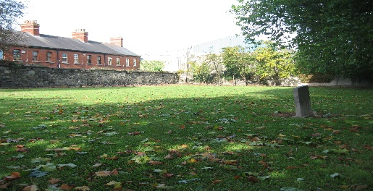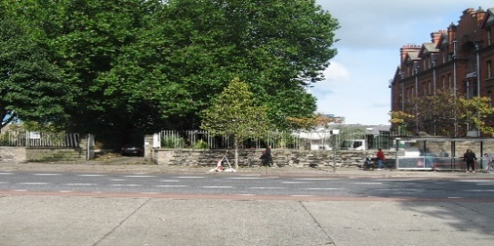

The only upright headstone Entrance and James Weir Nurses’ Home

Roy Pearson and Christopher Moriarty, Friends Historical Library

