Grave Markings and Headstones in Quaker Burial Grounds
and The Quaker Burial Ground in Cork Street, Dublin, in particular.

In the earliest days of Quakers, the 1650s, burial grounds were often acquired before any meeting house for their worship was built. Quaker beliefs prevented them from being buried in parish churchyards where the local "priest" would demand payment. Headstones were not customary in parish churchyards in those times.

Consistent with their rigorous disregard of outward symbols, Quaker burials would have been marked only by mounds. English Quaker records exist from 1710 of the rejection of a headstone, in Cornwall. In Lurgan Monthly Meeting, County Armagh, the practice of marking burials with sticks, until consummation was complete, was “desired to be forebeared with” as they “may tend to superstition and idolatory” and as “making crosses and other things may be invented by people of vain minds”. Headstones were tellingly described by a Friend in Philadelphia, as “being of no avail as regards the dead and but tend to gratify the pride and vanity of the living”. London Yearly Meeting decided in 1717 as “Friends in some places have gone into the vain custom of erecting monuments over the dead bodies of Friends” the Meeting advised “all such monuments should be removed” and “none be made or set up … for time to come”. Irish Friends had the same beliefs and similar practices but it was not until 1783 that Dublin Yearly Meeting decided that headstones should be removed and not used in the future.

So, for a long time after headstones came to be generally used in parish graveyards, Quaker graves were marked only by a gravemound. This contributed to the locations of some of the estimated 100 Quaker burial grounds in Ireland becoming forgotten and not being known nowadays. There has never been a Register of Quaker burial grounds. Nevertheless, Friends were careful since the mid-1650s, the earliest days of Quakers in Ireland, to record deaths and burials in Monthly Meeting minutes, in Monthly Meeting registers and at Quarterly Meetings. Furthermore, written memorials to deceased Friends were composed. These paper records, now retained in Friends Historical Library, have proven to be longer lasting than stone inscriptions.

Then in 1850, London Yearly Meeting came to the view that “it is no violation of [our] testimony to place over, or beside a grave, a plain stone, the inscription confined to … the name, age and date of decease of the individual. And, in 1856, Dublin Yearly Meeting decided that it was no violation of testimony for headstones to be used, provided, “to guard against any distinction being made in that place where the rich and poor meet together”, there be an entire uniformity in their materials, size and form. The inscription was to be similarly confined to a simple record of the name, age and time of decease of the person. The words of the 1856 Meeting permitting the stones included, “to place over a grave a plain flat stone, laid horizontally, … is no violation of … testimony”.
Both London and Dublin Yearly Meetings allowed headstones for interments before 1850 and 1856 when the location of the burial was remembered. In the Quaker burial ground in Cork Street, twelve stones predate the decision in 1856 to permit them.

So, how did all this affect Cork Street? It had been in use since 1697. It was closed for burials in 1868 as burials within five miles of a dwelling became legally prohibited. During the twelve years, when headstones were approved, until closure of the burial ground, eighteen headstones were placed there. They mark twenty burials between 1848 and 1859, mostly of persons in prominent Dublin Quaker families. Only one headstone is upright. It marks the burials of two children in 1852. The seventeen recumbent ones, must have been placed flat on the ground, in conformity with the decision allowing them to be placed “over a grave … laid horizontally”. It is of note that within the same twelve years, ending in 1868, there were fifty-nine burials without any headstone.

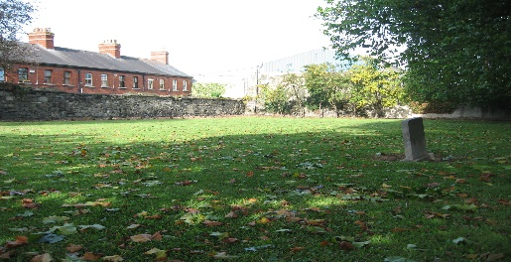
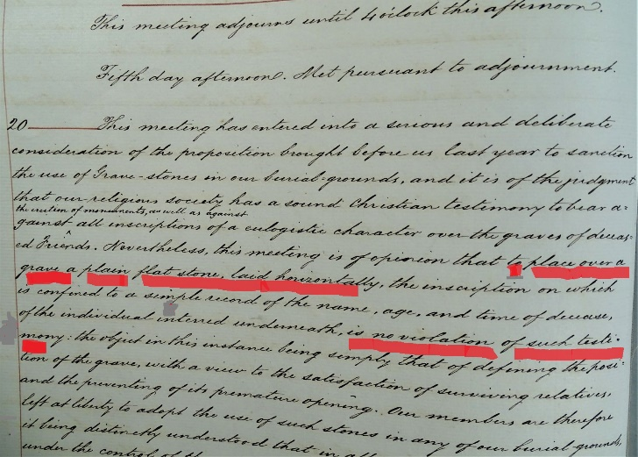
Part of Minute of Dublin Yearly Meeting 1856, with “to place, The only upright headstone in Cork Street
over a grave a plain flat stone, laid horizontally… is no
violation of … testimony”. underlined in red

This diagram shows where the eighteen headstones are located. It was prepared from a 1901 plan, before the adjoining Nurses home was built. Since then, only one gravestone, no. 3 for Hannah and Robert Goodbody, has been moved. It now rests on the ground close to the back wall.

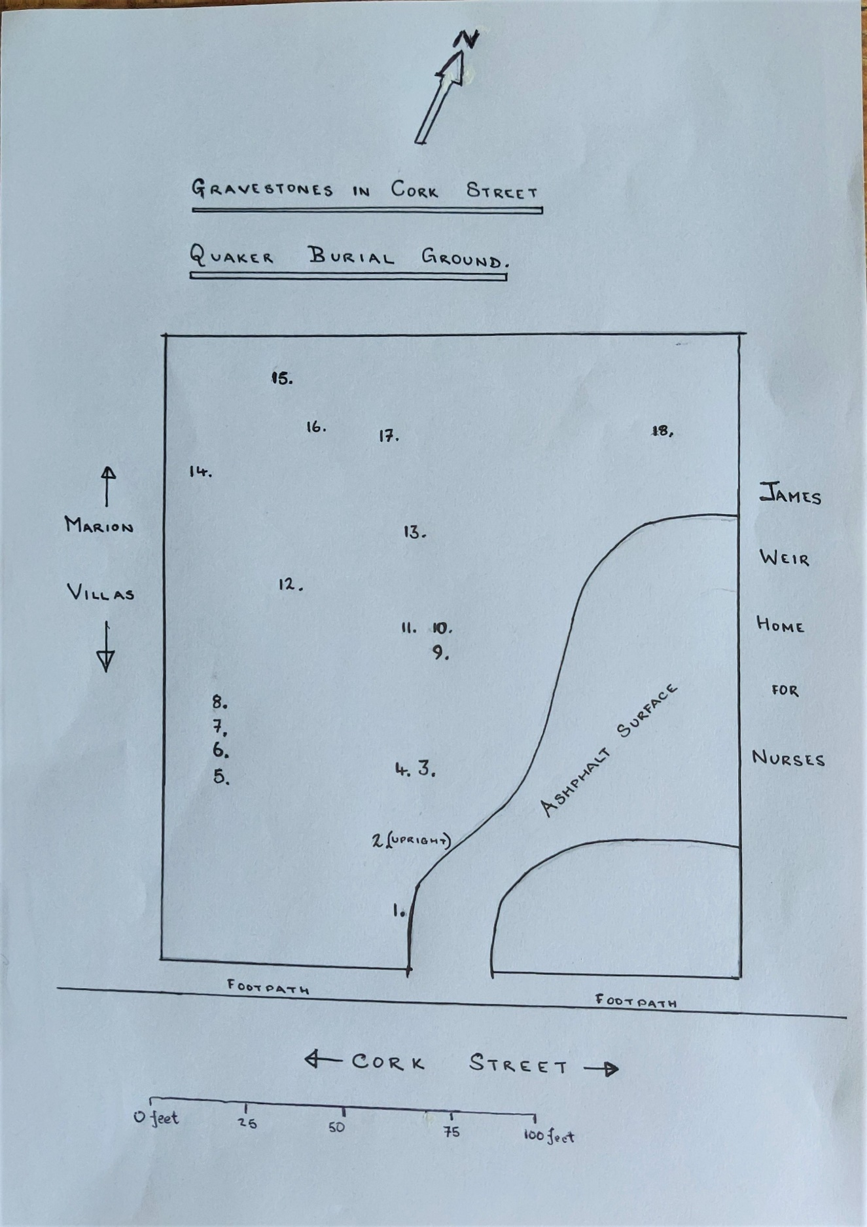

This chart gives the names, dates of death and the ages of those commemorated by the gravestones numbered 1. to 18.

Gravestone No. Name Date of Death Age

1. Edward Weston Allen 22.04.1848 83
2. Sophia Webb } 01.03.1852 7
Frederick Webb } 27.04.1852 3
3. Hanna Goodbody } 25.09.1848 2
Robert Goodbody} 11.12.1851 4
4. William Robinson 26.10.1849 62
5. Samuel Moss 15.05.1859 85
6. William Doyle 10.05.1859 72
7. Benjamin Glorney 05.05.1859 80
8. Lucy Garratt 07.03.1859 36
9. Joshua Edmundson 26.01.1848 42
10. Elizabeth Edmundson 07.08.1859 50
11. Charlotte Edmundson 18.10.1849 76
12. Reuben Deaves Pim 22.04.1855 17
13. Thomas Wright 26.03.1849 55
14. Mary Haslam 22.12.1860 75
15. Charlotte Pim 21.08.1854 21
16. Eleanor Tolerton 25.02.1854 23
17. Elizabeth Tolerton 22.10.1850 50
18. Samuel Tolerton 28.01.1856 37

Roy Pearson, Friends Historical Library
July 2021

Bibliography
David M. Butler, The Quaker Meeting Houses of Britain, 1999, London, Friends Historical Society, vol. II, appendix p. 902-905
David M. Butler, The Quaker Meeting Houses of Ireland, 2004, Dublin, Irish Friends Historical Committee, appendix p. 223-227
Copy map drawn in 1901 before the Nurses Home was built 1901, with gravestones numbered 1. to 18. Friends Historical Library, MSS box 107, no. 8b

