Truly Frank: A Dublin Memoir
by Frank McDonald

Review by Kieran Rose

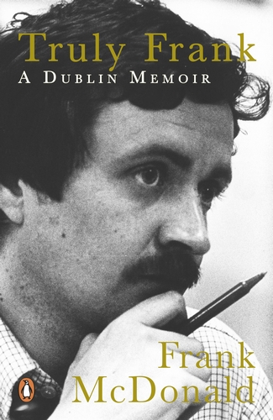
Frank McDonald's latest book, Truly Frank: A Dublin Memoir is a fine read; endearing and moving at times, revealing about his gay identity, and peppered with many a good anecdote. It is a significant contribution to the urban history of Dublin and the social history of Ireland, including gay history in this country.
McDonald writes warmly and affectionately about his mother, father, and his siblings and their happy home life. It was ‘an era of thrift, of make-do and mend, of waste not, wont not'. His mother was a great baker and in the run-up to Christmas the kitchen was turned into a 'virtual industrial zone for the production of plum puddings and cakes'. Names alone will trigger memories for those of us of a certain age: Ford Anglia, Volcano Kettle, Singer sewing machine. The Kennedys of Castleross, Monica Sheridan, and TVs with rabbit ears are all mentioned hallmarks of this period.
Moving towards the second half of the twentieth century, the reader is introduced to a Dublin being destroyed by both private developers and, what was then, Dublin Corporation. McDonald had a major role as a journalist and activist in attempts to save the city from what was almost terminal ruin, as evidenced in the Dublin Crisis Conference which he helped organise in 1986. His first book The Destruction of Dublin (1985) was hugely influential; ‘the most important book about Dublin written this generation', according to Daithi Hanley. Maurice Craig wrote that there is no use in pretending that McDonald was aiming at a dispassionate account, 'He's not. He is in a rage, and by the time the reader has finished he will be in a rage too.’
Recounting this period, McDonald notes how the book was almost not published because of a threatened injunction in the High Court by two individuals who were being written about. Told by his legal team that he needed more evidence to back up his claims, McDonald went to the High Court Central Office and found the proof he needed in the ten-year old records of a court case. The injunction was subsequently not pursued, and McDonald's seminal work was published.
In many other ways too, this most recent book is a memoir of fierce battles over tie city, many of which are well documented including the campaigns of groups such as Students Against the Destruction of Dublin. Some such stories of made and unmade plans are almost unbelievable in hindsight While undertaking research for his Irish Times article, for example, McDonald discovered road plans to turn the Dublin quays into a six-lane dual carriageway with the Liffey as a central median. He writes, 'I stood there in awe of their arrogance’ in treating the historic city in such a way.
On a more personal note, the book opens with a description of McDonald and his life partner, Eamon Slater, on a glorious day in May 2015, sitting on their terrace in Temple Bar listening to the waves of clapping and cheering from the delighted crowd in Dublin Castie as the votes were being counted in the marriage equality referendum. This was a transformed Ireland, different to the nation he had grown up in. As a child and beginning to realise that he was gay. McDonald writes that ‘gripped by Catholic guilt, I hated the idea of being "queer" and wondered if there was a cure". He describes the years of denial of his own sexuality, leading a double life, and how this left him emotionally, even psychologically, scarred. The 1993 law reform which saw the decriminalisation of same-sex activity 'was really quite liberating and I gradually realised that I no longer cared whether anyone knew I was gay'. Frank and Eamon were married in June 2016.
Kieran Rose is a planner and founder member/former chairperson of GLEN the Gay and Lesbian Equality Network

